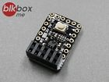

# **ESP8266 ESP-01 Programming and Development Tool Board (Auto-reset)**

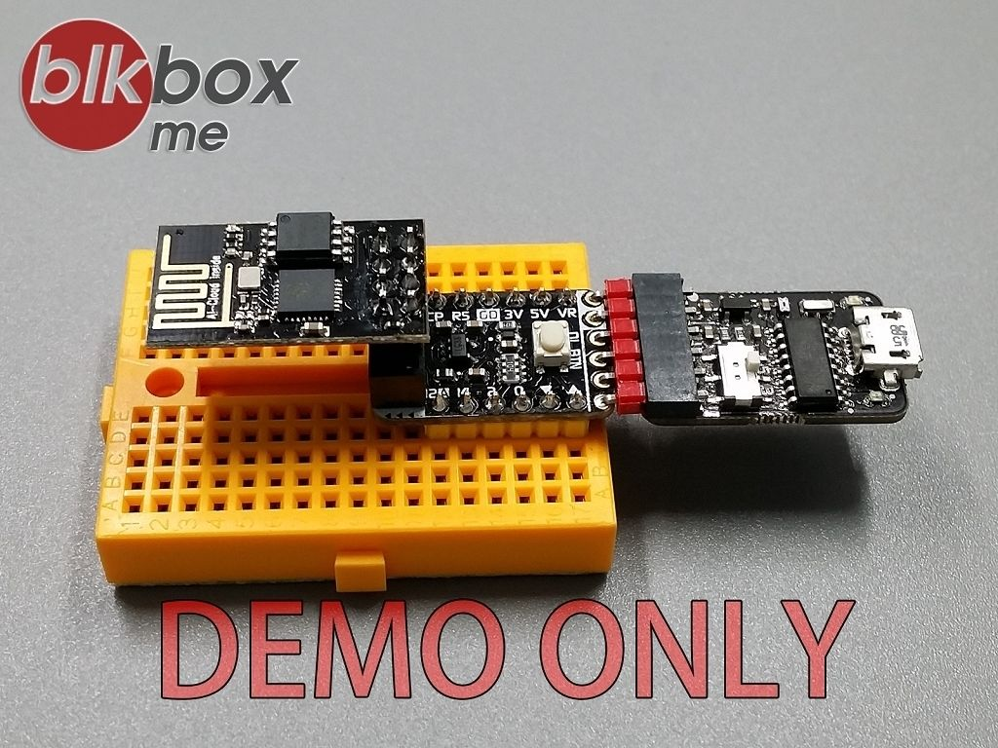

**ESP-01 Programming and Development Tool Board**



* **PART NO. "BB-E01ADP"**
* VR Power Input: **5V ~ 16V**.
* 3.3V Power Output Current Up to **350mA**.
* Automatically selects the power from VR or VUSB.
* Breadboard Friendly and FTDI Basic 5V Interface.
* It can be used in the BB-E01 or China ESP-01 **blue board(old)** / **black board(new)**.
* Built-in **Auto-reset** Function, Suitable for use in the Arduino IDE. FLASH DOWNLOAD TOOLS and any Terminal Software.
* Hold Down the "Download Button" before Downloading the Program, Release the Button after Entering the Download Process. (So Easy!)
* Board Size: 23 x 15 mm, 2x5 Socket only **5mm height**.
* Pin to Pin Pitch: 2.54 mm / 0.1 in.
* **Packing list**
  + BB-E01ADP x1 (As Photo1)

